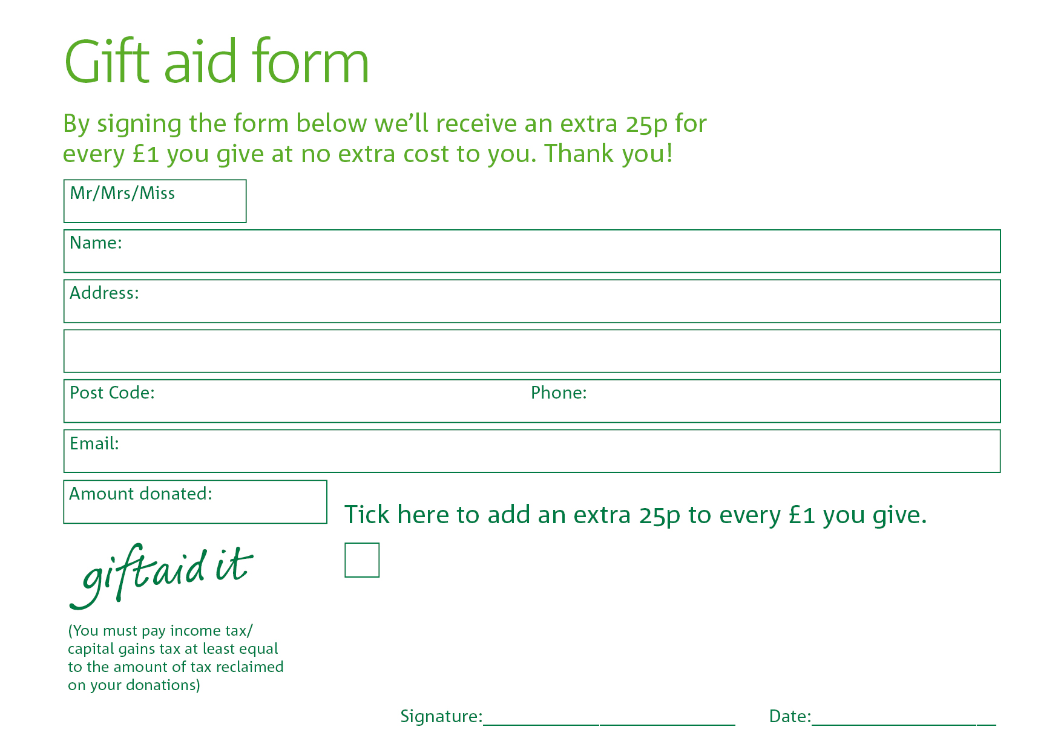

Yes, I pay tax in the UK. Please treat all donations I make or have made to The Trussell Trust for the past four years as gift aid donations until further notice. I confirm I have paid or will pay an amount of Income Tax and/or Capital Gains Tax for each tax year (6 April to 5 April) that is at least equal to the amount of tax that all the charities or Community Amateur Sports Clubs (CASCs) that I donate to will reclaim on my gifts for that tax year. I understand that other taxes such as VAT and Council Tax do not qualify. I understand the charity will reclaim 25p of tax on every £1 that I give.

PLEASE EITHER
Print this form, sign it and send with your donation to
Mrs Janet McLellan, Foodbank Treasurer, 127 Oaklands Park, Buckfastleigh TQ11 0BW
OR
Complete electronically, including typing your name in the signature space, save and attach to an email to info@buckfastleigh.foodbank.org.uk, sending your donation by BACS to
Buckfastleigh PCC Foodbank, sort code 40-52-40, account no: 00023172

Data protection

'Buckfastleigh Foodbank is committed to protecting your privacy and will process your personal data in accordance with current Data Protection legislation. Buckfastleigh Foodbank collects information to keep in touch with you and supply you with information relating to our work. To unsubscribe from our newsletter, send a message to the email address above with the word unsubscribe in the subject line. A full data privacy statement for financial donors is available from the foodbank on request.’

